**PEST SURVEY DATA OF REGION X (NORTHERN MINDANAO)**

May 2024

**Monitoring date:** May 2-15, 2024

**Provinces surveyed:** Bukidnon, Lanao del Norte, and Misamis Occidental.

**Number of Monitoring fields:** 164 monitoring fields (121 at fallow period, 6 just harvested, 11 at land preparation, 6 planted with other crops, and 20 planted with rice)

**Rice crop developmental stage:** Germination to maturity stage.

**Data collector/s:** John Kenneth Ortea, Henson Torres, Nap Ditchita, Jaymar Libardos, Jay Cabanes, Marietta Damu-Ag, Ricky Baje, Marietta Damu-Ag.

Table 1. List of monitoring fields with ≥5.00% average incidences on weed cover in Northern Mindanao on May 2024.

|  |  |  |  |
| --- | --- | --- | --- |
| **Field Code** | **Growth stage** | **Pest** | **Incidence (%)** |
| 100097 | Dough | Weeds | 5.00 |
| 100100 | Booting | Weeds | 5.00 |
| 100100 | Milk | Weeds | 5.00 |

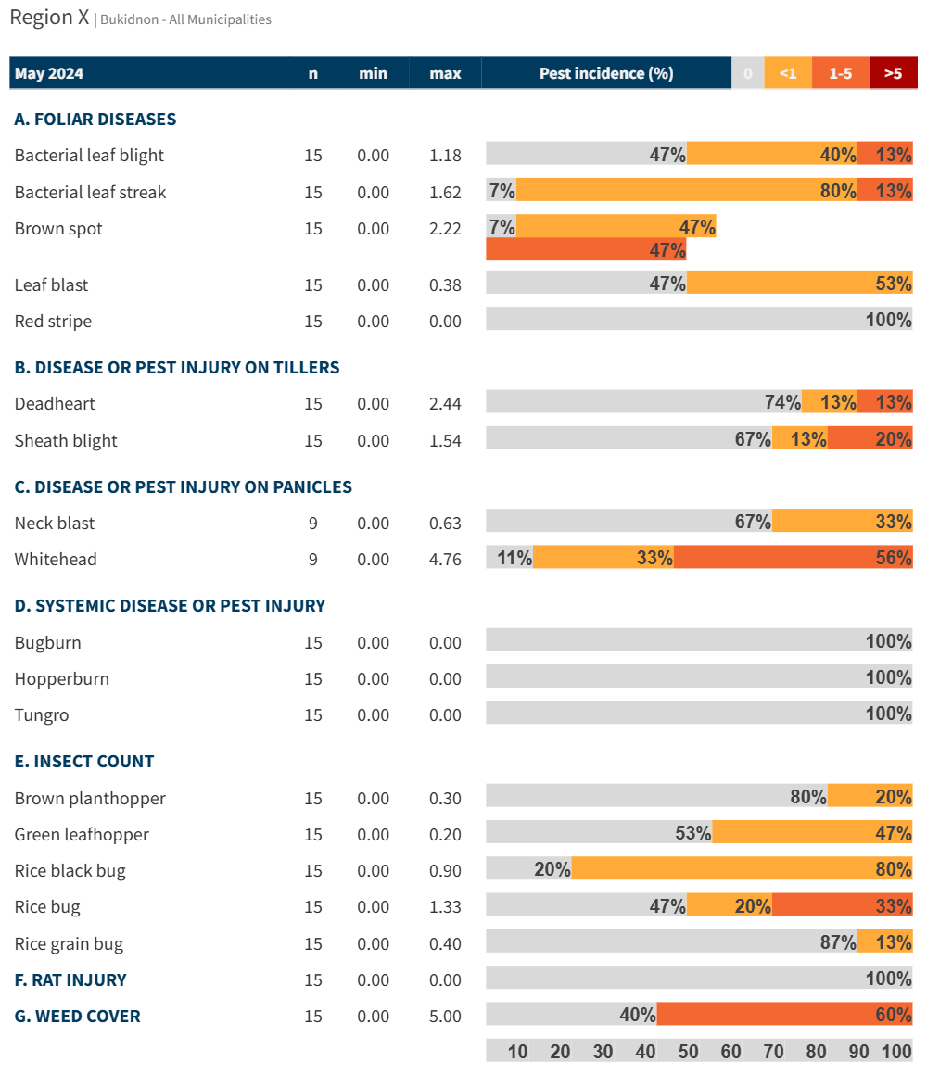 Figure 1. Incidence of pest injuries, counts of insect pests, and weed cover in Bukidnon on May 2024. Horizontal bar shows the proportion of fields in each range of pest injury incidence, insect count or weed cover.

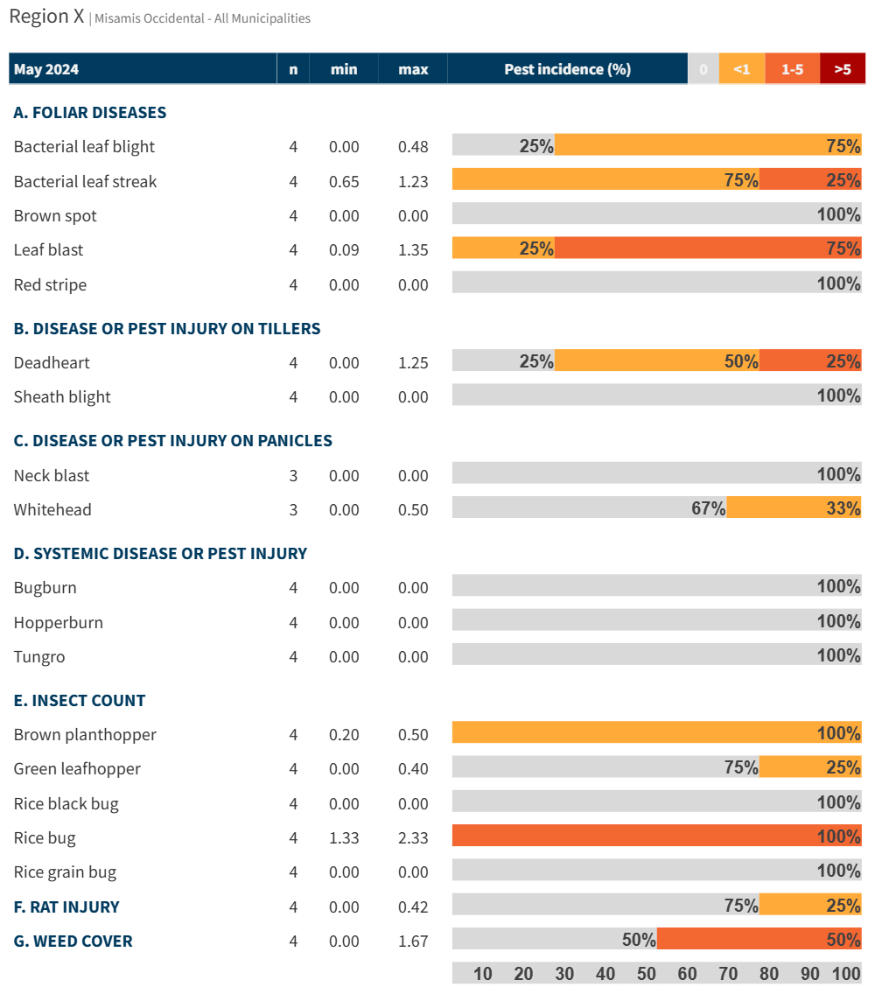 

Figure 3. Incidence of pest injuries, counts of insect pests, and weed cover in Misamis Occidental on May 2024. Horizontal bar shows the proportion of fields in each range of pest injury incidence, insect count or weed cover.