**PEST SURVEY DATA OF REGION V (Bicol Region)**

May 2024

**Monitoring date:** May 2-15, 2024

**Provinces surveyed:** Camarines Sur.

**Number of Monitoring fields:** 61 monitoring fields (41 at fallow period, 7 just harvested, 2 at land preparation, and 11 planted with rice)

**Rice crop developmental stage**: Seedling to maturity stage.

**Data collector/s:** Arnel Britania, Godofredo Balmeo, Raymark Sabio, Sherwin Dotillos, and Viner Sapinoso.

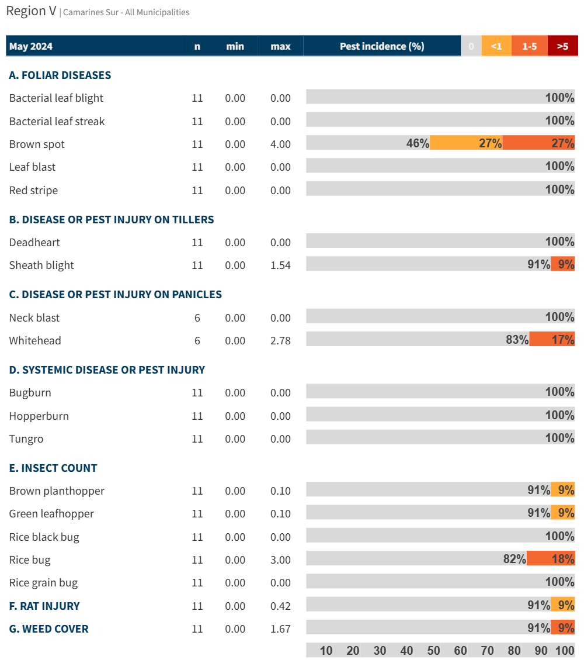 

Figure 1. Incidence of pest injuries, counts of insect pests, and weed cover in Camarines Sur on May 2024. Horizontal bar shows the proportion of fields in each range of pest injury incidence, insect count or weed cover.